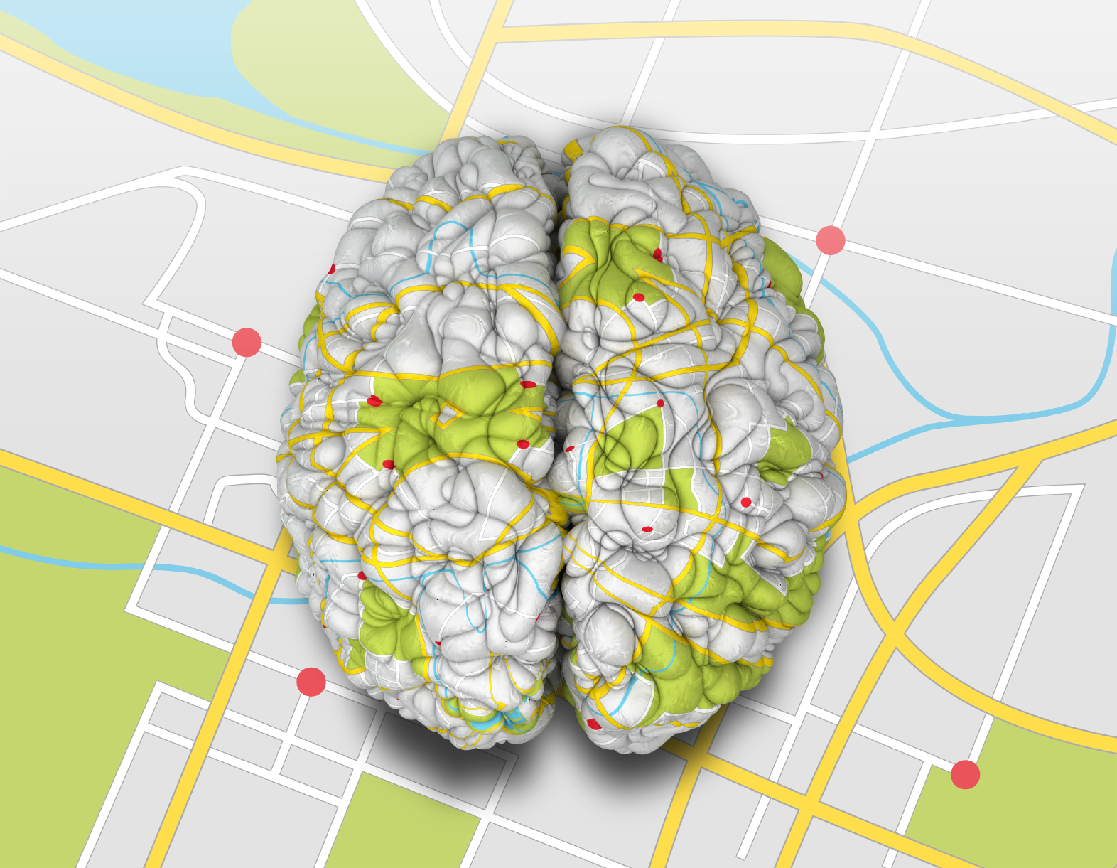

Neuroscience, Consciousness and Transformational Coaching
Certification Program Handbook
TABLE OF CONTENTS

Page 3 Program Overview
Page 3 Pod Communication
Page 3 Pod Calls
Page 3 Coaching on the Call
Page 5 Triad Calls
Page 5 One-to-One Mid-Program Connection
Page 5 Pre-Work and Homework
Page 6 Practice Clients
Page 6 Exams
Page 7 Completion and Designation
Page 7 Call by Call Schedule
Page 13 Tools and Handouts

CNTC Program Overview

Welcome to CNTC (Certified NeuroTransformational Coach) Certification! This manual is provided to help you navigate the program and (hopefully) answer all your questions.

Pod Communication – Facebook

Please be sure to friend ANN BETZ on Facebook so that she can add you to the closed group for your pod. (If you are not currently on Facebook, sorry, but you will need to join for the duration of this pod.) We use this platform for homework (see below for more details), pod communications, inspiration and sharing.

Calls

Certification is an 18-week class, broken down as follows:
- Fourteen 1.5 hour pod calls with entire group of six
- Three 1.5 hour calls with small groups of three
- 1 one-to-one check in call with one of the leaders
- Please see the Xcel spreadsheet for your pod for exact dates of each of these calls, as well as triad assignments and dial-in number.

Each 1.5 hour pod call is loosely structured as follows:
- 60 minutes teaching, discussion or process on the topic for the week
- 15 minutes coaching with 15 minutes feedback – usually 1 person coaches each time; however, on two calls there will be two coaches. Each person coaches twice in program and is client twice
- Please see week-by-week breakdown below or Xcel spreadsheet for topics by week and coach/client assignments.

There are 25 CCEUs available from CNTC Certification, which will be sent within two weeks of final call.

Coaching on the Pod Call

Assignment of coaches and coachees
Each week, one or two pre-assigned coaches will coach one or two pre-assigned coachees from the group. We give you these assignments in advance so that you can prepare the tool you are using, and the client can prepare a topic, which, although real, is coachable using that tool.

If you are unable to be the coach or client on your assigned week, please reach out to the group to see if someone can swap with you. (Your pod leaders will not do this for you .)

Setting up the coaching
As the coach, we ask that you assume the coachee does not have a background or familiarity with either the Seven Levels or the neuroscience concept being used. This is the only role-play of the coaching—the rest should be authentic, on a real topic of importance to the coachee. The reason for this is that we want to give you experience practicing introducing the tool and/or concept, as well as a chance for the rest of the pod to hear how you do it!

Coaching preparation—important!
Please also be thoroughly prepared to use the tool and concept. All handouts and background are included in this manual for your convenience. If you don’t remember it well or don’t feel confident using it, we ask that you reach out to your fellow pod members for help and advice. (We ask that you do this instead of asking your pod leaders because we know the answers are within the group, and it deepens the learning for everyone.)

The purpose of this coaching is two-fold: one, to give each of you two chances to coach in front of the group and receive feedback. The second is for the entire group to experience the tool demonstrated, which is why it is very important that each coach be fully prepared. Because of this, if you, as the coach, come onto the call not prepared to coach the tool you have been assigned, we’ll pass the coaching baton to someone else who is ready, and you will miss one of your opportunities for coaching and feedback.

Feedback on Your Coaching
Even the word “feedback” can evoke an amygdala hijack in the best of us. We also often know a fair amount about what worked or didn’t work ourselves. In this program, we want to make sure that feedback is both relevant and accessible to you, the coach, so we have developed the following process:

- Step One—we ask what you are most proud of in your coaching. This is important, and is also often the most difficult part.
- Step Two—we ask where you would point yourself for your greatest learning.
- Step Three—we ask what feedback YOU would like from the leader, the client and/or the group. This is your chance to design what is most useful to your growth.
- Step Four—the leader provides some verbal feedback per your design/request.
- Step Five—the group offers their feedback per your design/request.
- Step Six—the leader sends a written feedback form, which focuses on both technical aspects (for example, were you accurate with the neuroscience?) as well as feedback on the space you held for the client.

Triad Calls

There will be three Triad Calls during the program. Each pod’s triads are scheduled on slightly different weeks, so please refer to your pod’s spreadsheet for times and who is in each triad (we usually mix up the groups so that you are not with the same people each time). You are responsible for how you want to connect—through a conference line, Skype, or other group call technology.

The purpose of these calls is to practice coaching. On the triad call, arrange to have each person coach for at least 15 minutes, with time for feedback. Use any of the tools we have discussed to date—we recommend that each person use a different tool.

One to One Mid-Program Connection

Approximately midway through the program (again, see spreadsheet for your pod’s week) you have the chance to connect one to one with one of the leaders. The purpose of this call is simply to check in, see how you are doing, and be available for any questions. It’s not an assessment or test, just time for you to share or ask what you want. About two weeks beforehand, we’ll send out a list of which leader you are meeting with, and possible times for this conversation.

Pre-Work and Homework

Prep work
Each week, there will be readings and/or videos to review in preparation for the call. See the call-by-call breakdown below for links to each call’s prep work. Generally, readings or videos should take no more than 30 minutes at most.

Also, please review the coaching tool that will be used on that week’s call, whether or not you are the assigned coach or client!

Homework
Please post your answers to the homework assignment(s) (some weeks there are both theory and practice assignments) in the appropriate HOMEWORK document (listed by week) in the FILES section of the closed Facebook group for your pod. You can see each week’s assignment in the call-by-call breakdown; they are also listed at the top of each document on Facebook. In addition, please note completion of each week’s homework in your Homework and Hours Log (we will send this to you as a Word doc). This log must be sent to patricia@beaboveleadership.com before scheduling your final exam.

Posting on FB
In the FILES section of your pod’s closed group there is a homework document for you to post in following each group call. We ask that you post your homework following the group call for that week, and before the next group call. There is no homework on the weeks where there are triad calls.
To post your homework, click on "edit doc" and put your name in bold, followed by your answers and reflections on that week's homework. If others have already written in, just scroll down to the bottom and add yours after the most recent person. Please don’t add additional documents – it’s important that the homework all be in one place for your fellow pod members and leader’s ease of access.
Also, please don't post homework on the main page. We'll use that for more casual connections, interesting articles, funny stuff, and general community connections. (The only exception is when the homework requires posting of a drawing or photo, which will need to be done on the main page and not in the FILES section.)
Practice Clients
You are required to have 5 practice clients with whom you will be using neuroscience and Seven Levels tools with during this program, for a total of 20 coaching hours (you can track these hours from the start of your certification program). We provide you with a homework and hours log in a Word doc format for tracking. This log needs to be turned in to patricia@beaboveleadership.com before scheduling your final exam.

Exams

Written exam
The written exam covers the main concepts of the Seven Levels and Neuroscience, and is pass/fail. We don’t grade these other than that – if you pass, you pass! If you don’t pass, we’ll let you know the specific questions we need more/better/different on, and give you another chance to pass. There is no additional charge for this. (If you don’t pass a second time, we’ll design a strategy with you – there may or may not be an additional charge at that point.)

The written exam will be sent out as a Word doc immediately after the final call. It is due back to both leaders within two weeks.

Oral exam
This is a half-hour exam with either Ann or Ursula. You will coach for 20 minutes, using a neuroscience tool (no Seven Levels tools on the exam, please). Assume that your coachee has no background in neuroscience and introduce the tool as you would with someone new. Your coachee will bring a real topic she wants to work on. We’ll provide scheduling information and instructions towards the end of your pod. Note: homework and hours must be complete before scheduling oral exam. Depending on your written exam, there may be some additional questions about aspects of neuroscience.

You will be notified within one week as to whether or not you passed. If you did not pass, you will be given specific feedback as to why, and offered an additional opportunity to coach the other pod leader. There is a $100 re-take fee for oral exams.

Completion and Designation

After passing both exams, you will receive a certificate acknowledging your new designation: Certified NeuroTransformational Coach (CNTC), and will be listed as a certified coach on our website. (You’ll receive instructions as to how to do this at that point.) You are also then eligible to attend our Train the Trainer and licensing program, which allows you to use the Seven Levels and Neuroscience tools with groups and organizations.

****************************************************************************************

Call-by-Call Schedule

During the 18-week program, there are 14 large group calls, three triads, and one call with one of the leaders. The following schedule covers the topics, pre-work and homework for each of the large group calls. Please refer to your pod’s spreadsheet for the exact date of each of these calls, as well as the assigned coach and client.

(Reminder: post the answers to your homework in the correct file for that week in the FILES area of your pod’s closed FB group.)

NOTE – there are various links in the homework section. Sometimes news agencies change the URL and we are not aware. If links don’t work, please cut and paste into browser and you will either get directly to article or to search page where you can find article.

CALL ONE

Topics: Designing our alliance, getting to know each other
Pre-work: Think about agreements you would like to have as part of designing our alliance:
- What is the experience you want to have as part of this group?
- What are some agreements that would support making that experience real?
Homework: Go through the Seven Levels and give examples of how each level speaks.

(NO COACHING on Call One)

CALL TWO

Topic: The Seven Levels of Effectiveness
Tool: Circle Process
Pre-work: Review Seven Levels ebook, focusing on brain and bio-chemistry of each level. Also review the new Seven Levels brain matrix in Tools and Handouts section below.
Homework:

1) THEORY:
Write two to three paragraphs on each of the following questions:
- Explain the “big picture” nature of the levels. In other words, what are some general things people need to know?
- Explain the role of courage in shifting levels

2) PRACTICE:
- Look at a place you are below the line in your own life. It could be a relationship, a habit, a judgment of self or others. Focus on shifting this by using tools from the Seven Levels. Notice and write about the process –what did you try, what was the impact? Reach out to your fellow pod members for coaching and support.
- Do the same with one of your clients. Notice and write about what worked or didn’t work.

CALL THREE

Topic: The Seven Levels, part two
Tools: Walking the Ladder and Speaking from Above to Below
Pre-work: None
Homework: Write a short story (fiction) or poem, or make a drawing or cartoon that captures some essential essence of the Seven Levels for you. (NOTE: if you make a drawing or cartoon, post on main FB page and note that it is your CALL THREE homework because you will not be able to post in homework file.)

CALL FOUR

Topic: Neuroplasticity, part one
Tool: Red Lines/Blue Lines (yarn process)
Pre-work:
- Watch http://www.youtube.com/watch?v=iAzmyB9PFt4
- Read http://www.time.com/time/magazine/article/0,9171,1580438,00.html

Homework: Use the red yarn / blue yarn process with a client who is not familiar with it. Pay close attention to what works or doesn’t and post your insights here!

CALL FIVE
Topic: Neuroplasticity, part two
Tool: 5 keys to Neuroplasticity
Pre-work: Review Five Keys handout (see Handouts and Tools section), also read http://www.newyorker.com/magazine/2015/08/24/my-brain-the-all-hands-meeting

Homework:

1) THEORY
- Take one of the five keys and find a scholarly article which supports this key (this means not just a blog or popular article, but as close to the original research as possible). Share the link and a couple of paragraphs about why you think this study supports it so well.
- Extra credit – find a study that supports one of the following enhancers: relationships, humor, play
2) PRACTICE
- Use Five Keys wheel with a client and let us know the impact!

CALL SIX

Topic: The PFC
Tool: PFC Curve
Pre-work: Read The Goldilocks of the Brain on yourcoachingbrain.wordpress.com
Homework:

1) THEORY:
Write one to two paragraphs on the following questions:
- What are some of the verbal cues a client is in TOO MUCH?
- What are some of the verbal cues a client is in TOO LITTLE?

2) PRACTICE:
- Spend at least a day noticing your too little, too much and just right. You may want to set a timer on your phone to remind you every hour to check your PFC and make a note of how you feel. Notice the impact of being in too little, too much or just right. Share your insights on FB.
- Coach a client using the PFC curve and write a paragraph below of your best advice to the rest of the class on how to do this successfully.

CALL SEVEN

Topic: Coaching and Stress
Tool: Stress Management by Effectiveness
Pre-Work: Review handout and notes from class
Homework:
- Notice your own stress levels this week and how it affects your ability to think. Practice using one of the ways to manage stress on yourself. Write about what happens.

- Coach a client using the stress management by effectiveness tool – go all the way through starting with “name the emotion,” and post a paragraph of your best advice to the rest of the class on how to do this successfully.

CALL EIGHT

Topic: Two Hemispheres
Tool: 100/100 and Diagonal Process
Pre-work:
- Read the introduction to The Master and His Emissary --http://www.iainmcgilchrist.com/The_Master_and_his_Emissary_by_McGilchrist.pdf
- Read “Right Brain Left Brain, is it all a Myth?” http://yourcoachingbrain.wordpress.com/2014/01/09/right-brain-left-brain-is-it-all-a-myth/

Homework:

1) THEORY:
Write one to two paragraphs on the following questions:
- How do you know your client may be lost in their lower left hemisphere?
- How do you know your client may be lost in their lower right hemisphere?

2) PRACTICE:
- Use 100/100 or Diagonal Process with at least one client. Report your results.

CALL NINE

Topic: Task Positive Network, Default Mode Network
Tool: Crossing the River
Pre-work: Read https://yourcoachingbrain.wordpress.com/2015/02/06/the-power-of-dreaming-the-power-of-action/

Homework:

1) THEORY:
Write one to two paragraphs on the following question:
- What are some cues (in addition to what is on handout) that it is time to switch from DMN to TPN, and from TPN to DMN?

2) PRACTICE:
- Use Crossing the River with at least one client. Report your results.

CALL TEN

Topic: Wounds and Healing Fields
Tool: Wounds and Healing Fields
Pre-work: Review handout and notes from class
Homework:
1) THEORY: Find a poem or story (or even a novel) which reflects one of the wounds and share your thoughts as to what it tells us about this wound and how it plays out in a person’s life. Include a short summary.
2) PRACTICE: Share the wounds and healing fields with at least one client. Share your results.

CALL ELEVEN

Topic: Embodiment
Tool: Literal Coaching
Pre-work: Read "Where Mind Body Meet" (posted in FILES section)
Homework:

1) THEORY:
Write a 2-3 paragraph personal reflection on “Where Mind Body Meet.” What did this article mean to you, personally? (You don’t need to analyze or be academic here.)

2) PRACTICE:
Have at least 5 LITERAL COACHING moments in your coaching this week. List what you did below. (For example: “My client said they felt like they were between a rock and a hard place, and I had her stand between her bookcase and the wall.”) Add a bit on the impact of doing this!

CALL TWELVE

Topic: Intuition System
Tool: Metaphor process
Pre-work: Review handout and notes on the Human Intuition System
Homework:

1) THEORY:
Write one to two paragraphs on the following questions:
- What makes sense to you about the intuition system?
- Where are you strongest?
- Weakest?
- What can you do to develop your system more?

2) PRACTICE:
During your week, as stressful events occur (from mild to extreme – “good” stress or “bad” stress), send a spoke of awareness down your core. What do you feel, what do you notice in your body? Don’t try to change anything. Post on FB what you noticed for three of these events.

CALL THIRTEEN
Topic: The coach’s energy and presence
Tool: Blessing and intention, 10 words
Pre-work:
- Read these articles:
  - https://well.blogs.nytimes.com/2011/01/28/how-meditation-may-change-the-brain/
  - http://www.npr.org/templates/story/story.php?storyId=104310443
- Coach one or more clients and read the coaching invocation before the call – notice the impact.

Homework:

1) THEORY:
Write one to two paragraphs on the following question:
- What do you see about the impact of the coach’s presence on coaching?

2) PRACTICE:
Use the coaching invocation with at least five clients and also don’t use it on a few clients. Post on FB what is different about coaching when you do so.

CALL FOURTEEN

Topic: Completion and Celebration
Pre-work: Reflect on what you want to celebrate about yourself and others in the pod.
Homework: Written exam, due back to leaders within two weeks.

TOOLS and HANDOUTS

On the following pages (14-33) are tools, handouts and coaching instructions for each pod call of this program. All are simply copies of what you have already received in the Neuroscience, Consciousness and Transformational Coaching program Modules One to Four, but they are the most up to date versions, so some minor things may be different. Be sure to take a look at the tool of the week before each class, and confer with your fellow pod members if you have any questions about the tool or concept (especially if you are the coach that week).

There are also other handouts from the program that may be helpful, as well as your own notes and “So What?” cards of course. We recommend assembling all of your materials and notes in preparation for the Certification program.

BRAIN RESPONSE ABOVE AND BELOW THE LINE

ABOVE THE LINE | SYNCHRONICITY  (Mastery) | INNOVATION  (High Competence) | ENGAGEMENT  (Moderate Competence) | COURAGE  (Very Inconsistent)
Level of Brain Integration, amygdala to PFC (recovery from stressful situations and triggers) | Masterful, recovery is seamless, there is little time lag, and it is often unnoticeable | Highly competent, recovery is fast and dependable, but there will be some time lag | Moderately competent, may not always recognize when triggered, but can recover when aware | Very inconsistent, can recover but often needs support to do so, often highly unaware of triggers
Level of Brain Integration—RH/LH  (Seeing and working with both details and connection, logic and meaning, data and relationship) | Masterful, use both with seamless ease | Highly competent, able to switch back and forth between them as needed | Moderately competent, may not always recognize when to switch, but can do so when aware | Very inconsistent, can do occasionally, needs practice and support
Dominant Brain Chemicals | RELIABLY NON-SITAUATIONAL RESPONSE (internal peace)  Balanced adrenaline and dopamine (PFC function), oxytocin very active, low cortisol | OFTEN NON-SITUATIONAL, OCCASIONALLY SITUATIONAL  Balanced adrenaline and dopamine (PFC function), oxytocin somewhat active, low cortisol | USUALLY SITUATIONAL RESPONSE  Less reliably balanced adrenaline and dopamine, oxytocin may be active, cortisol may also be active | ALMOST ALWAYS SITUATIONAL RESPONSE  No reliable balance of adrenaline and dopamine, oxytocin sporadic, cortisol activated
Impact on Body/Health | Body is reliably calm, health potential optimal | Body is generally calm, health potential good | Body is sometimes calm, but sometimes distressed, health potential ok (somewhat compromised) | Body is existing in a state of general mild distress potential compromised in comparison to other ATL levels
Awareness of Others (theory of mind, empathy, sense of impact of actions) | Always aware of others’ perspectives and needs, this comes without effort | Generally able to incorporate others’ perspectives naturally as part of worldview | Able to stand in someone else’s shoes when calm and balanced, this is not completely reliable | Very limited awareness, awareness of impact limited by adrenal response of courage
Impact on Others (mirror neurons, sensory influence) | Reliably inspire peace and calm in others | Usually inspire recovery from triggers, open-mindedness | Unreliable impact on others because less aware of own internal state and ability to regulat4e | Create mild distress, others feel slightly off-center
Influence of Others  (bringing BTL energy) | High sensitivity, so very aware of others’ brain states, able to monitor and regulate in self | Competently aware of others’ brain states, usually able to monitor and regulate in self | Not generally aware of others’ brain states, less ability to monitor and regulate in self | Not aware of others’ brain states, little ability to monitor and regulate in self

BELOW THE LINE | FRUSTRATION  (Fight) | FEAR  (Flight) | HOPELESSNESS  (Freeze)
Level of Brain Integration, amygdala to PFC (recovery from stressful situations and triggers) | Highly unpredictable, often uninterested in recovery, also chemical response can be so strong recovery is impossible in the moment | Almost completely run by amygdala, very easily triggered, low ability to recover, may recover from one trigger only to self-activate another | No ability to recover, stressful situations define personality (their story becomes who they think they are), if recovery comes, it takes a long time and tremendous support
Level of Brain Integration—RH/LH  (Seeing and working with both details and connection, logic and meaning, data and relationship – RH Chaos, LH Rigidity) | Dis-integrated, lives in LH Rigidity | Very dis-integrated, bounces wildly from one hemisphere to the other (from Chaos to Rigidity), often ending up in Chaos | Completely dis-integrated, generally living in RH Chaos
Dominant Brain Chemicals | Adrenalin, cortisol, other inflammatory agents, and dopamine (through interest in achieving highest status) | Adrenalin, cortisol, other inflammatory agents | Cortisol, other inflammatory agents
Impact on Body/Health | Energy fueled by adrenalin, may risk depleting adrenal glands, health also impacted through process of inflammation, more concern about heart impact here | Energy fueled by adrenalin, may risk depleting adrenal glands, health also impacted through process of inflammation | Very poor, no energy, health may be severely impacted through process of unrelenting inflammation
Awareness of Others (theory of mind, empathy) | Awareness of impact and others’ views and needs limited by strong influx of dopamine and norepinephrine in PFC | Awareness of impact and others’ views and needs limited by strong influx of norepinephrine in PFC | Awareness of impact and others’ views and needs limited by lack of norepinephrine in PFC
Impact on Others (mirror neurons, sensory influence) | Triggers adrenalin and cortisol response in others, also dopamine-seeking behavior (competition) | Triggers adrenalin and cortisol response in others | Create low energy in others, feelings of despair
Influence of Others  (to inspire ATL) | Others can have some influence, but are battling the addictive nature of dopamine, however with strong energy may have positive influence | Others have some influence, but productive brain state not sustainable without constant support and reassurance | Little influence, the only thing that works at all is absolute unwavering unconditional love, however, they are somewhat impermeable

Us/Them • Scarcity • Limits • Reaction • Accusation • Shame • Blame • Guilt
Betrayal • Resignation • Apathy • Complaints • Manipulation • Obsession
Resistance • Righteousness • Should • Doubt • Win/Lose • Resentment • Brooding Greed • Revenge • Living in the Past/Future • Jealousy • Hatred • Isolation Inadequacy • Embarrassment • Force • Anxiety • Rejection • Depression Inferior/Superior • Suspicion • Criticism • Sarcasm • Loneliness • Dominance Ignorance • Judgment • Competition • Sadness • Interrogation • Ridicule • Closed
Right/Wrong • Exclusion • Anger • Separateness • Boredom • Hurt
Irritation • Cynicism • Egotism • Craving • Dispiritedness
Respect • Excitement • Serenity • Security • Ease • Appreciation • Hope Awareness • Contentedness • Intimacy • Nurturance • Sensuality • Worthiness Curiosity • Connection • Courage • Peace • Beauty • Holiness • Sharing • Faith Innocence • Cooperation • Embracing • Openness • Possibility • Grace •Balance • Allowing • Groundedness • Sustainability • Nourishment Collaboration • Bliss • Delight • Compassion • Forgiveness • Inspiration Acceptance • Trust • Prosperity • Creativity • We • Learning • Gratitude
Integrity • Vision • Choice • Freedom • Joy • Celebration • Presence • Play
Love • Harmony • Objectivity • Motivation • Tolerance • Bravery • Resolution

THE CIRCLE PROCESS

- Choose something where you are Below the Line.
- What percent are you Below and what percent Above? Draw line and write in percentage.
- What are some of the words that resonate Below? Write them in.
- What are some of the words that resonate Above? Write them in.
- Choose the word Below and the word Above that have the most resonance.
- Explore the feeling of each word chosen (BTL and ATL) as well as embodiment.
- Brainstorm, how can you bring the Above word to the Below word? Be creative!
- Commit to one action.
- Check to see percentage now.

WALKING THE LADDER
- Coachee pick something they are either BTL or ATL (or unsure) about
- With coach, look at this from each of the seven levels, starting in Hopelessness
    - What is true here?
    - What does it feel like to be here?
    - What do you notice? What wisdom is here?
    - What is the embodiment of how you feel here?
- After exploring all seven, have coachee choose the level they want to stand in going forward
- What actions (Being or Doing) are they motivated to take from this level?
- Commitment and accountability
Additional Questions for Walking the Ladder:

HOPELESSNESS
o What’s hopeless
o What do you want to give up on
o What are you sure won’t work
FEAR
o What are you afraid of
o What’s the worst that could happen
o What’s risky
FRUSTRATION
o What makes you mad
o What is irritating
o What’s frustrating
COURAGE
o What could you try
o What might be possible
o What risk could you take
ENGAGEMENT
o What would be fun
o What would keep you in the game
o What’s the contribution you want to make
INNOVATION
o What’s the bigger picture/stake
o What’s an out of the box possibility
o Where you can let go of your personal agenda
SYNCHRONICITY
o What is perfect about this
o What is or could be magical
o What would love do

SPEAKING FROM ABOVE TO BELOW
- Client start where they are on ladder.
- Speak from here—what’s true. Use “I” language.
- Client goes above (any level) and speak to BTL self. Use “you” language.
- Go back and forth as needed until ready to choose a level.
- Coach holds space – let client coach themselves! Do not “coach” when above or below, just ask, what do you say from here (using “I” language below and “you” language above) and notice when it is time to switch.

Neuroplasticity Coaching (red and blue yarn)
- Coachee, think of something you are “below the line” about
- Coach ask:
  - Where are you laying down red strands about this issue?
  - What are the blue strands that are there as well?
  - Where do you want to focus your attention?
  - What would create more blue strands for you?
  - What do you need/want to stop or diminish?
  - One action in the blue.
3) Lay down red or blue yarn as appropriate

Neuroplasticity—Keys and Enhancers

Neuroplasticity is, simply put, the capacity of the brain to change throughout life. It can occur on a variety of levels, ranging from changes due to learning or growth, to large-scale changes in response to injury. While for most of the 20th century general consensus among neuroscientists was that brain structure is relatively unchanging after early childhood, current understanding is that many aspects of the brain remain plastic—that is, changeable—even into adulthood.

Extensive research has found there are certain keys to neuroplasticity, without which it is more difficult (and sometimes impossible) for the brain to make neuroplastic changes. There other aspects which assist with or enhance the process. In both cases, the more keys/aspects, the better.

Five Keys to Neuroplasticity
The following five keys are necessary to the process of making new neural connections. The more one of more of these keys is compromised, the harder it will be for the brain to stay flexible, healthy and cognitively sharp, especially through aging and stress.

1. Exercise
Exercise improves blood flow and increases oxygen levels, which increase neuron growth. (The brain is only 2% of our body mass but it consumes 20% of our oxygen and nutrients.) Exercise also increases the volume of white and grey matter in the brain, by increasing brain-derived neurotropic factor (BDNF), which is necessary to neuronal growth. A minimum of 30 minutes three times a week is generally recommended, although shorter workouts of more intensity and longer with less are helpful as well.

2. Sleep
A healthy adults needs between 7-9 hours of sleep (Teens need 8.5 – 9.25 hours). During sleep our brain has the chance to integrate learning and also combs through information and decides what is needed and what is not. Neural impulses are literally reversed from our waking state, which serves to both clean out unneeded information and prime the cells for learning and memory in the future.

3. Food
The brain needs Omega-3s and vitamins from foods to create new neural pathways. It’s also critically important to stay away from foods and substances that inhibit neural growth and/or create inflammation. According to new research, aspartame and other artificial sweeteners, high fructose corn syrup, alcohol, vegetable oils and many grains may all contribute to non-optimal brain states. Promising research finds coconut oil, berries, B vitamins (and much more) helping to build neural connections in the brain.

4. Novelty
New experiences stimulate neuronal connections. If we don’t know how to do something, the cognitive patterns for it don’t exist in our brains, thus new connections must be made. In order to maintain the benefits, however, these experiences have to increase in challenge in order to create new growth. Additionally, we simply don’t pay attention to things that are boring!

5. Focus and Attention
The close paying of attention (as in study, meditation and focused attention) increases neurotransmitters (such as BDNF, mentioned above in the Exercise section) responsible for creating new neural connections. In addition, many studies have linked meditation practice to differences in cortical thickness or density of gray matter.

Four Enhancers to Neuroplasticity
The following four enhancers are extremely helpful to the process of making new neural connections. The more we have of each, in combination with the five keys, the easier it is to learn, remember, and change.

1. Relationships
We learn and change best in safe, supportive relationships. Feeling socially connected diminishes stress and can even reduce inflammation, while feeling judged or “less than” others creates fight or flight responses in the brain which inhibit learning. When we feel we are being heard and understood, it increases the connective neural fibers in our brains—fibers that are crucial for bringing together disparate areas for increased cognitive function.

2. Mistakes
A critical part of the learning process is the ability to try, fail, recalibrate and try again. This is literally how the new neural connections we make get either strengthened or pruned. According to Daniel Coyle in The Talent Code, training “at the edge of our abilities” produces results up to 10 times faster than regular practice. That is, making mistakes leads to better skill acquisition. Directly linked to the key of novelty, making mistakes is inherent to increasing the difficulty of the task. As long as we are making mistakes, the task is probably challenging enough.

3. Humor/Play
Humor relaxes and bonds us, and is a wonderful ally in helping to overcome the brain’s strong negativity bias. Laughter has been shown to release oxytocin, which not only makes us feel more bonded and connected and trusting, it’s also a great anti-inflammatory agent. Good humor also often plays upon the unexpected, causing us to think in new ways (novelty). Similarly, being playful puts the brain in an open state for learning. All baby animals and humans learn through play, which allows mistakes to be made and learned from in a safe environment.

4. Multi-Sensory Input
The more multi-sensory neural connections we have associated with a behavior or skill, the stronger the “pathway” becomes by engaging more aspects of the brain. For example, when we remember a vacation to the beach, we may access sounds, smells, sights, even the feeling of sand on our toes. This anchors in the experience more strongly than simply seeing a photo of sand and waves. When we are intentionally working to create positive new neural pathways, bolstering this process by bringing in as many of our senses as possible is a fabulous strategy.

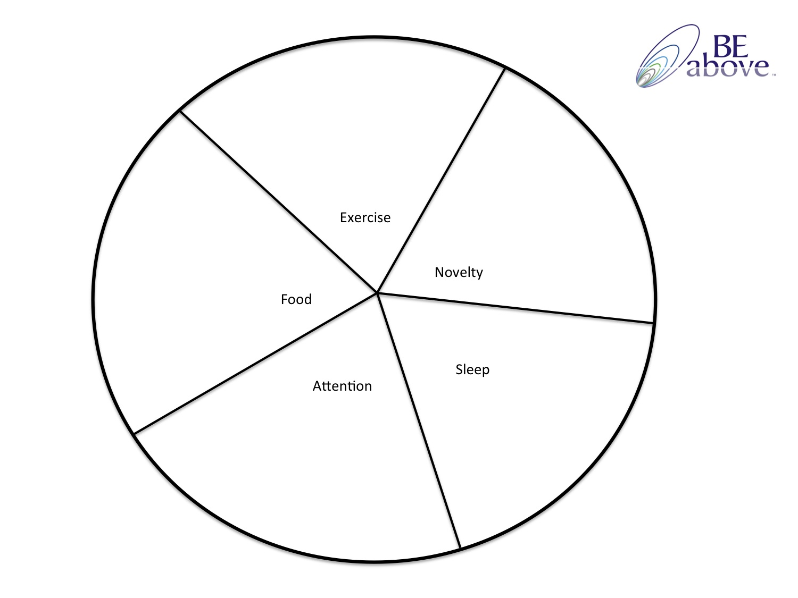
Neuroplasticity Coaching (Keys and Enhancers)
- Coachee fill out wheel – what is the current reality in each KEY area?
- Coach and client choose area to focus on increasing
- Look to see how enhancers can help increase key

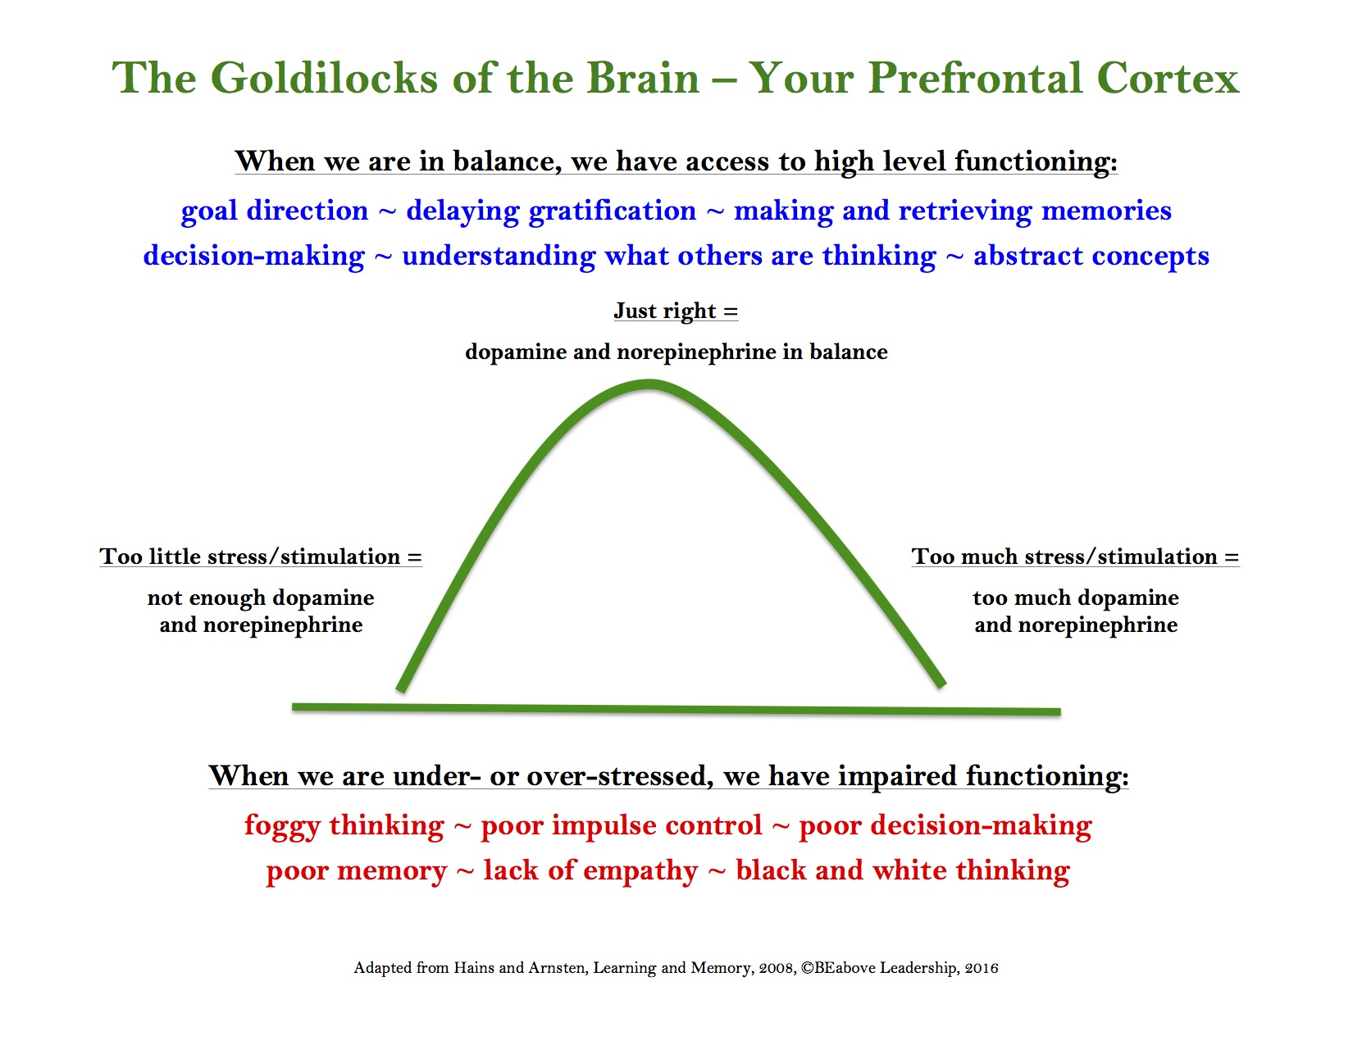
The Pre-Frontal Cortex (Goldilocks) Coaching
Coachee choose a place you know you are in “too little” or “too much”
Coach:
- What is it like where you are? Feelings, embodiment.
- What takes you there?
- What might bring you up (from TOO LITTLE) or back (from TOO MUCH)?
- Where will you choose to put your focus to bring yourself to grounded center?
Tools for Managing Stress
In order of effectiveness
- Suppression (not effective)
Although tempting, suppressing emotions is not an effective strategy. It has been linked to depression, and most experts agree that suppressed emotions find ways to “leak out” when not acknowledged and addressed in some way. We also tend to think that we can hide out emotions from others, but research shows that sitting next to someone who is upset and suppressing will raise your blood pressure (and the suppressor’s as well).
- Naming the emotion
Research shows that simply naming an emotion reduces amygdala activity. This is certainly the simplest and easiest tool in the coach’s toolkit for helping a client manage stress, although some clients may need to build this muscle—the coach can help them expand their emotional vocabulary and practice this skill.
- Controlling the Environment
This is probably the most effective strategy – nothing is better than actually removing the source of stress – however, it ranks low on the list because it is only effective in those cases where it is possible to do so. We can’t control everyone and everything in our lives, and attempting to will only create a net increase in stress. Still, where possible, this is a great strategy.
- Values and Life Purpose
Research shows that reflecting on meaningful values and life purpose serves as a buffer to stress. This strategy engages the pre-frontal cortex and gives clients a broader context for their lives, a container for decision-making and a map for future direction.
- Reframing
The act of reframing (also known as taking a new perspective or reappraisal) also activates the pre-frontal cortex, calming down our stress responses. Reappraisal has been touted by some neuroscientists as one of the most important skills a human being can develop for their mental health and life success.
- Mindfulness
Mindfulness seems to be the most effective solution to any neuroscience challenge, from stress, to creativity, to improving memory, and even being more emotionally intelligent. As coaches, much of what we do helps our clients become more “mindful.” Even just a good coaching conversation brings people present into the moment and makes them pay attention to what is going on, rather than putting their attention on regrets from the past or worries about the future. Additionally, we can encourage clients to meditate, and use guided meditation and other focusing tools within the coaching session.

Managing Stress Worksheet
(Based on Tools for Managing Stress)

- NAMING. What am I feeling right now?

What might be underneath that feeling?

Note: if you can’t figure out how you are (or client is) actually feeling, go to the Circle Process or simply pull out the circle with words as a reference.

- CONTROLLING THE ENVIRONMENT. In this situation, what can I change, do differently, or control?

- VALUES AND LIFE PURPOSE. What is important to me in this situation?

In this situation, what values do I want to honor?

- REFRAMING. What is another way of looking at this situation, maybe one I haven’t yet thought of?

If I stood in someone else’s shoes, what would this situation look like?

- MINDFULNESS. Take a moment to breathe and connect with your body. Draw in at least 4 deep full breaths and exhale down to your toes. In ten words or less, what do you see now about this situation?

RH/LH Coaching Tool: Diagonal Thinking
INTEGRATION
 | LEFT | RIGHT
A  T  L | POSITIVITY  FOCUS AND DIRECTION  LOGIC  SEQUENCES  FOCUS ON PARTS  ANALYSIS | COOPERATION  SEE THE WHOLE  FOCUS ON BROADER MEANING  INSPIRATION  EMPATHY  INSIGHT
B  T  L | ANGER  BLAME AND DENIAL  CONFORMISM  USE PEOPLE FOR OWN GAIN  DENY EVIDENCE  RIGIDITY | HOPELESSNESS  EMOTIONAL OVERWHELM  SADNESS  FEAR  PESSIMISM  CHAOS

Coachee pick a topic where they are Below the Line:
- Which hemisphere is dominant (go there)?
- What does it feel like here?
- What do you say from there to self and others?
- Go to the “helper” hemisphere (diagonally Above the Line)
- What does this hemisphere feel like/say from Above the Line?
- What does the other hemisphere feel like/say from Above the Line?
- What does Integration say?
- Action from Integration?
Right/Left 100/100 (Metaphor)

1) Below the Line

My RIGHT HEMISPHERE at its worst is:

A metaphor for my RIGHT HEMISPHERE BTL:

My LEFT HEMISPHERE at its worst is:

A metaphor for my LEFT HEMISPHERE BTL:

2) Above the Line

My LEFT HEMISPHERE at its best is:

A metaphor for my LEFT HEMISPHERE ATL:

My RIGHT HEMISPHERE at its best is:

A metaphor for my RIGHT HEMISPHERE ATL:

A metaphor for my INTEGRATED BRAIN is (two ATL hemisphere metaphors connected):
The Default Mode Network and the Task Positive Network
The Default Network (DMN) and the Task Positive Network (TPN) are two distinct neural networks in the brain. The DMN is a network of brain regions that are active when the individual is not focused on the outside world and the brain is at wakeful rest. It’s called “default” because it is the network that is activated unless we are specifically engaged in goal-directed activity, the realm of the TPN.
NOTE: While some of the aspects below may sound similar to Right and Left Hemisphere operations, each network actually includes both.
Task Positive Network | Default Mode Network
- Focus on task  - Actively paying attention (external)  - Goal-orientation  - Reacting to and working with sensory information  - Short-term (working) memory  - Planning  - Abstract reasoning | - Dreaming  - Envisioning the future  - Long-term memory  - Gauging other’s perspectives  - Theory of mind (understanding others)  - Introspection  - Self-referential thought

Because the DMN is activated when we are daydreaming, imagining the future, pondering our own thoughts and beliefs, and trying to understand others, it deals more with the being side of things, as contrasted by the TPN which is activated when we are doing or focused on doing.
Probably one of the most interesting aspects of these two networks is that when the DMN is active, the TPN is not. And when the TPN is active, the DMN is not. Part of each network’s function is to shut the other down. Perhaps even more than the right and left hemisphere, the DMN and TPN interaction helps explain why being integrated can be so challenging. When we are dreaming, reflecting, and standing in someone else’s shoes, the neural network concerned with action is not “on line.” And when we are planning and acting, the network associated with creating vision and understanding others is shut down.
By holding an integrated view, whether in terms of coaching, leadership, or life in general, we create a dance between these two networks. Many coaching tools are, in fact, designed to activate one or the other, whether it is envisioning our “future self” (Default Mode Network) or planning what we will do next (Task Positive Network). By holding focus on both the being and the doing, we can’t help but create connections between the two networks, so that even if only one can be activated at a time, it becomes easier and easier turn on the switch of the other and shift back and forth more and more quickly.

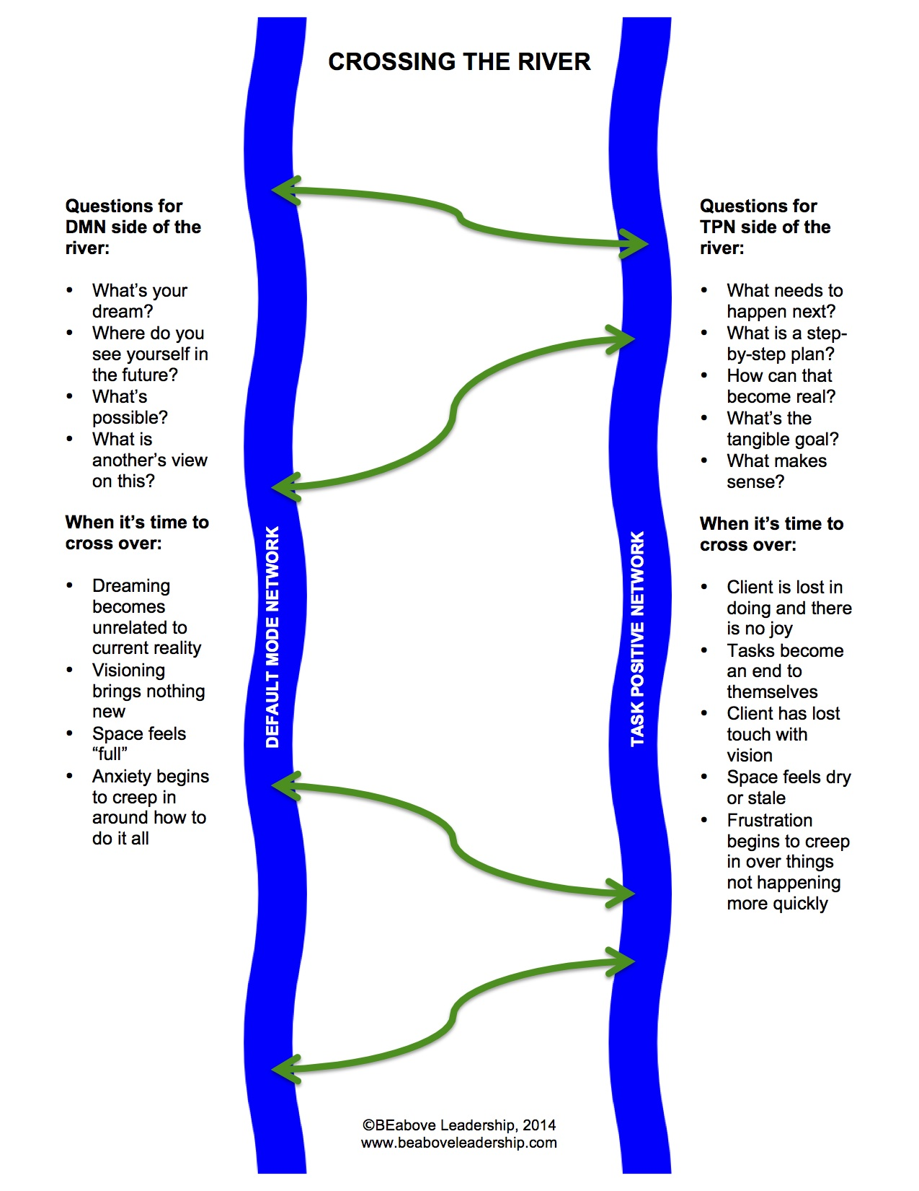

Below the Line Wounds and Healing Fields

The three Below the Line levels are the three primary places we get pulled when stressed or upset. While we all can go to any one of these levels, we each tend to have a primary default level where we go more often than the other levels. Each corresponds to a key emotional state, and some research shows that our wounds may have been created by early experiences of these emotional states. The three emotional states are:

Level/ Emotional State | Feeling/Impact | Bio-chemical  Response / Disease | Ways it is Caused
LEVEL ONE:  Hopelessness  EMOTIONAL STATE:  Shame | Hopelessness  Disconnection from self and others  Feels hot, flushed | Pro-inflammatory response in the body (shame feels to the body as if it is being attacked)  Auto-immune diseases | Criticism  Blame  Judgment  Bullying  Calling names  Mean teasing  Guilt trips
LEVEL TWO:  Fear  EMOTIONAL STATE:  Abandonment | The urge to flee  Feels cold in the body | Adrenalin  Cortisol  Cancer | Neglect  Being ignored  Being left/abandoned (physically and emotionally)  Dismissal  Parent-child role reversal  Not being taken seriously  Lack of interest/support
LEVEL THREE:  Frustration  EMOTIONAL STATE:  Betrayal | Anger  The urge to fight  Feels hot, burning | Adrenalin  Cortisol  Heart Disease | Being lied to  Being cheated (cheated on)  Broken trust  Agreements not kept  Being talked about maliciously/unfairly  Meanness/unkindness  Abuse  Responsibility not taken
Any one of the emotional states can lead to anger, but the prime emotion will be felt first

WORKING WITH THE HEALING FIELDS
Each BTL wound/emotional state has a corresponding Healing Field: the healing field for Shame is Honor, for Abandonment is Commitment and for Betrayal is Value. When you are feeling these states, you can bring the appropriate healing field to yourself. When you have caused one of these states in another (and yes, we all do, often not intentionally) you can bring the appropriate healing field and heal the relationship. So if someone feels like you have shamed them, you honor them somehow. If they feel abandoned, you focus on your commitment to them. If they feel betrayed, you stress their value to you.
TIP: To bring a healing field to yourself, first look at what it would look like to really bring it to another. Then do these things for yourself. (Your brain is generally not that interested in you healing yourself because it means revisiting a painful place, therefore it helps to sort of “trick” your brain!)
Emotional State & Healing Field | For Yourself | For Another
Shame = HONOR  HONOR is so powerful it will heal all wounds | Be with the emotion without judgment or suppression  Put yourself first and stop sacrificing yourself for others  Treat yourself as an honored guest  Speak only kind words to yourself  Spoil yourself with beautiful food and surroundings; wear your best clothes  Speak of your wounds/failings with tenderness and love  Stand up for yourself and set boundaries  Ask for what you need and make self care a priority  Be grateful for yourself | Acknowledge their true self  Treat them as beloved teacher/guest  Speak to what is beautiful in them  Find the brilliance in what they do and say  Listen deeply and be attentive  Take a deep interest in who they are  Ask if they have what they need  Respect their boundaries  Be present with them  Create a welcoming environment  Meet their eyes with kindness and love
Abandonment = COMMITMENT  COMMITMENT will heal both Abandonment and Betrayal | Tell yourself that you love yourself  Say to yourself “I am here for you, I won’t abandon you”  Keep your word to yourself  Develop self-awareness and grow  Trust your inner guides  Follow your dreams  Make yourself a priority  Allow and voice your true feelings  Invest in yourself (time and money)  Allow yourself to be proud of yourself | Apologize and re-commit  Promise to honor your commitments to them fully (and then do it)  Make them a priority  Be honest and trust them (even if they don’t trust you – yet)  Help them love and believe in themselves  Invest in them (time and money)

Betrayal = VALUE | Stand up for yourself  Make appropriate boundaries  Focus on your own strengths and talents  Acknowledge yourself  Validate your own feelings  Apologize to yourself  Express yourself fully  Honor your values  Create / live into a vision for yourself  Take note of compliments and reflect on accomplishments  Take time for yourself | Apologize and commit yourself fully  Tell them how important they are to you  Acknowledge them  Emphasize their strengths, talents and gifts  Co-create and align on values and vision  Listen to them without being hooked—be open and non-resistant  Take responsibility for your part in it all  Celebrate and appreciate  Hold them Naturally Creative, Resourceful and Whole  Be forthright with kindness

Wounds and Healing Fields: COACHING FOR INTEGRATION

- Explain model and “diagnose” default level (or share model and ask client which wound resonates with them)
- Ask client: what created this wound? (Use worksheet for reference.)
- Get curious about their experience, what’s it like? Allow the experience.
- Share the Healing Fields with client, focus on the field for their wound
- Ask client, how would you bring this field to another? (Helps to get them in the experience of the field without resistance). In other words, if you wanted to HONOR someone else what would you do?
- Then ask client, how would you do this for yourself? (Can help them brainstorm with strategies from column three.)
- Have client commit to one thing.

Embodiment Coaching

- Coach on any topic
- Tune your listening very acutely for the metaphors the client uses in their speech
- Have them embody exactly what they are saying. For example:
  - I feel a really up today – have them stand up, or stand up on something
  - I’m stuck between a rock and hard place – find two things to stand between
  - I can’t seem to get moving – either stand absolutely still, or move around
  - I’m feeling flat – get as flat as you can
  - I’m playing on the skinny branches – walk as if you were walking along a branch
  - I need to think outside the box – make a box of chairs or tape on the floor and think inside it. Then step outside.
- As they do this, what do they notice?
- Have client stay in present—what wisdom is here?

Ten Words or Less

- Coach gets ten words or less at a time.
- Client gets ten words or less at a time.
- Client can’t speak again until coach speaks their ten words.
- Coach can’t speak again until client speaks their ten words.
- Keep going past the point of comfort, but not to the point of too much frustration (a little is ok!)

THE HUMAN INTUITION SYSTEM

Intuition is: anything we know without conscious processing, thought, or observation

The system consists of three areas with sub-areas of each:

1) The Brain

- Context (Memory of Experience)
- Right Hemisphere of the brain – recognizes everything new and holds mirror neurons for empathy
- Left Hemisphere of the brain (and integration of both hemispheres) – ability to focus on and work with new information coming in through the RH
- Mirror Neurons
- Default Mode Network

2) The Body

- Heart and Gut Neurons
- The Heart’s Resonant Field
- Vagus Nerve
- Sensory Information

3) The Collective Consciousness

- Quantum entanglement
- Morphic resonance / inherent memory
- Epigenetics
- Attunement
- And more…..

The Metaphor Process

- Have your client choose something they feel below the line about.
  - Ask what is the emotion (easiest to use big categories of hopeless, fear, anger).
  - Ask client to close eyes and get present to where this emotion is in their body.
  - How strong is it on a scale of one to ten? (Write this down.)
- Tell your client that you are going to ask a series of questions about the emotion.
  - Encourage them to take the first thing that comes to their mind without judgment, even if it doesn’t make sense. Tell them not to worry if they don’t get anything, just go on to the next one.
  - Let them know they will be choosing ONE at the end and not to worry about remembering, just stay in the moment. You’ll repeat the metaphors back at the end.
One at a time, fill in the blank: If this emotion were a ________________, what would it be? (NOTE: you may want to use between 3 and 5 of these, depending on the client’s energy. You also may want to write them down to be able to repeat them to your client at the end.)

  - Flower/Plant
  - Stone/Mineral
  - Body of water
  - Article of clothing
  - Music
  - Animal/Bird
  - Body part
  - Kichen utensil

- Repeat the metaphors and ask your client – which of these has the most resonance for you?
- Tell me more about this metaphor. What does it look like? Describe it.
- Now I want you to step into your metaphor and actually BE it. Put your body into the posture of this thing. Really be it and feel it.
- Explore the experience with your client. Questions to ask:
  - What does it feel like to be _________________?
  - What is good about being __________________?
  - What else is good about it, what is its gift?
- Important – ask them this question. (The answer is almost always that it wants to be loved, allowed or even left alone – these are all ways of granting it the dignity of existence.)
  - If you were to step back from being this metaphor for a moment, what do you notice it wants from you? Go ahead and give it what it wants.
- Now ask your client to write a new number next to the original number they had next to their emotion. Debrief around the shift and/or insights.

The BEabove Coaching Invocation

I am an open invitation for everything _______________________ (my client) is, wants, and brings. I ground myself in love for him/her, and trust that my knowledge, skills and tools are more than sufficient for what is needed by him/her now.

I connect myself to the highest aspects of my being and allow love and trust to flow between me and _________________________ (my client). I trust that in some way our higher selves are communicating, and there is movement and healing happening in this space as well as through the coaching that will occur.

I honor myself for being of service, and I honor ______________________ (my client) for his/her courage and desire to make shifts and have growth in his/her life.

OPTIONAL: I ask (insert anything you find appropriate here – God, Angels, Universal Energy) to participate in ______________________’s growth and healing, and I ask that my words be guided for the highest good of all concerned.

The BEabove General Invocation

I am an open invitation for everything my life is, brings and needs. I ground myself in love for all events, people and circumstances that come my way. I trust that my knowledge, skills and tools are more than sufficient for what is occurring and needed now.

I connect myself to the highest aspects of my being and allow love and trust to flow between me and all that I encounter. I trust that in some way my higher self is shaping things for movement and healing, and I surrender to this trust.

I respect myself for being of service, and courageously engaging with life. I honor my desire to have growth and healing in my life and the lives of those around me.

OPTIONAL: I ask (insert anything you find appropriate here – God, Angels, Universal Energy) to assist me on my path, and I ask that my words and actions be guided for the highest good of all concerned at all times.

Based on the work of Dr. Mario Martinez, www.biocognitive.com

