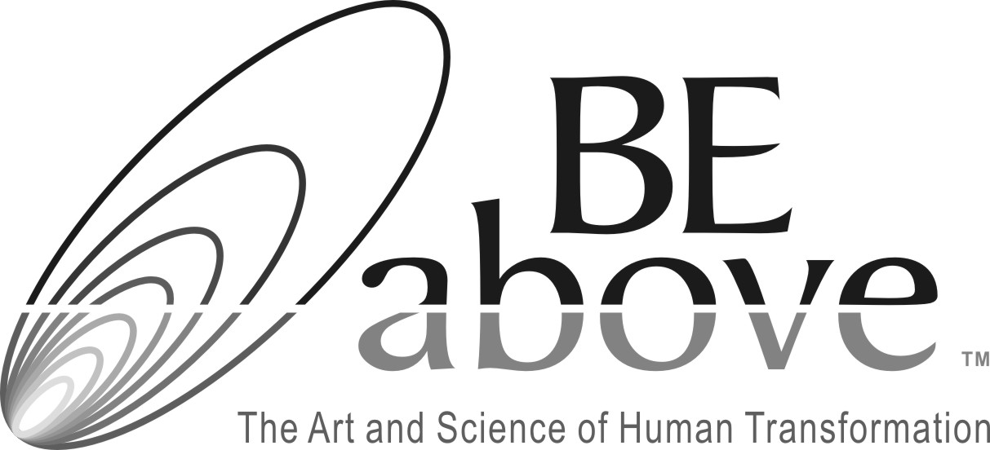

The BEabove Coaching Invocation

I am an open invitation for everything __________________________ (my client) is, wants, and brings. I ground myself in love for him/her, and trust that my knowledge, skills and tools are more than sufficient for what is needed by him/her now.

I now connect myself to the highest aspects of my being and allow love and trust to flow between me and _________________________ (my client). I trust that in some way our higher selves are communicating, and there is movement and healing happening in this space as well as through the coaching that will occur.

I honor myself for being of service, and I honor ______________________ (my client) for his/her courage and desire to make shifts and have growth in his/her life.

OPTIONAL: I ask (insert anything you find appropriate here – God, Angels, Universal Energy) to participate in _____________________________’s growth and healing, and I ask that my words be guided for the highest good of all concerned.

The BEabove General Invocation

I am an open invitation for everything my life is, brings and needs. I ground myself in love for all events, people and circumstances that come my way. I trust that my knowledge, skills and tools are more than sufficient for what is occurring and needed now.

I connect myself to the highest aspects of my being and allow love and trust to flow between me and all that I encounter. I trust that in some way my higher self is shaping things for movement and healing, and I surrender to this trust.

I respect myself for being of service, and courageously engaging with life. I honor my desire to have growth and healing in my life and the lives of those around me.

OPTIONAL: I ask (insert anything you find appropriate here – God, Angels, Universal Energy) to assist me on my path, and I ask that my words and actions be guided for the highest good of all concerned at all times.

©BEabove Leadership, 2013, www.beaboveleadership.com

