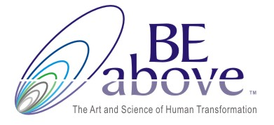

The Art of Getting What You Want – Experience and Form

Experience | Form
LEVEL OF EFFECTIVENESS: 4+ | LEVEL OF EFFECTIVENESS: 1-3
We create it with our five senses and often with our sixth sense (intuition) | We look at job title, location, facts
We connect to the feelings, we imagine | We are attached to the outcome and focus on the “HOW”
There is no attachment to time, to the “how” or as to “what” it will show up | We are attached to the actual thing - the form
It is about what I want - the feeling, the experience, not how (or when) I will get it | We worry about the timetable and the to do list
“If I don’t get this, something even better will show up” | “If I don’t get this, it will be bad” or “What am I going to do if….?”
We trust – we receive everything with trust | We are addicted to control and the need to know for sure
We co-create with spirit and take inspired action from there | We focus on do-do-do- we drive it, and try to force it
We believe in it without seeing it (yet) | We need evidence to believe in it
We focus on the feeling, trusting that the outcome/goal will be aligned with feeling | We focus on the outcome/the goal and hope that the feeling will be aligned
We are present in the here and now, and focus our energy inwards | We live in the past or present, scattering our energy outward

The trick is to learn an unwavering focus upon your desired “end result”— the feeling, your completed dream, the experience, the finish line—without insisting upon or even contemplating its means of attainment, no matter how logical, obvious or tempting it may seem.

www.BeaboveLeadership.com

