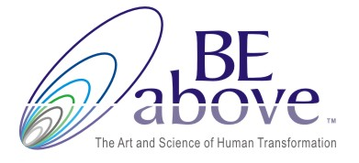

Recommended Books

Mindsight, Daniel Siegel -- True stories of real profound changes and healing. I can't recommend this book highly enough.

The Neuroscience of Psychotherapy, Louis Cozolino -- in my opinion, probably the best book for coaches out there, although he focuses on therapists

Coaching with the Brain in Mind, David Rock and Linda Paige -- I use this for reference. It's very detailed and complex and perhaps not an easy cover to cover read, but I find it very helpful for looking things up.

The Brain that Changes Itself, Norman Doidge -- wonderful true stories of "neuroplasticity" and astonishing ways the brain can find new ways to do things.

Incognito, David Eagleman -- also an easy to read book, lots of true stories about how we know what we know.

My Stroke of Insight, Jill Bolte Taylor -- a wonderful book about right brain/left brain, written by a neuroscientist who had a stroke. Also TED talk:

http://www.ted.com/talks/jill_bolte_taylor_s_powerful_stroke_of_insight.html

The Art of Changing the Brain, James Zull -- this may be the best book on learning and the brain for educators.

Your Brain at Work, David Rock -- good for leaders, very business focused.

The Buddha's Brain, Rick Hanson with Richard Mendius -- a great introductory book on the brain that weaves in mindfulness and Buddhist wisdom and includes practical tools for personal development.

In the Realm of Hungry Ghosts, Gabor Mate -- fabulous work on the neuroscience of addiction.

The Master and His Emissary, Iain McGilchrist -- amazing, powerful work on the right and left brain. The RSA video is also fantastic and only 11 minutes or so:

http://www.youtube.com/watch?v=dFs9WO2B8uI)

Scientific American Mind and Psychology Today

